How to Scan a Thin Section:

Below are the settings required for thin section scanning,

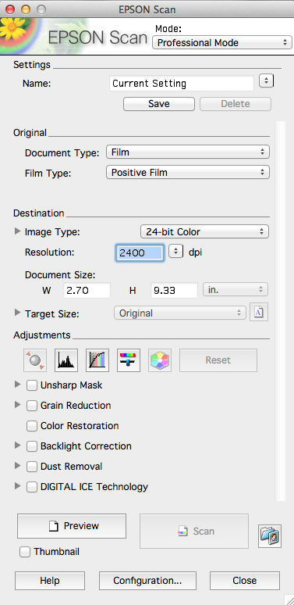

To set up the scanner:

- Remove the white background board from the scanner (replace when you’re done).
- When placing the thin section on the scanner leave a 1-inch strip of space at the top of the scanner. Don’t place anything here.
- Clean the thin section and the scanner with a Kimwipe before scanning.
- Place the thin section in the center of the scanner (between the two rectangles seen at the top of the screen.
- Click preview before you scan to make sure your thin section is in the field of view.
- Click scan.
- Change the document name, location, and file type (.jpg) in the menu that comes up.

To scan in cross-polarized light:

- The polarizing sheets are in the middle drawer below the scanner in the computer room. (PUT THESE BACK WHEN YOU’RE DONE.)
- Place one polarizing sheet vertically on the scanner, the thin section on top of it, and the other polarizing sheet perpendicular to the first on top of the thin section. See scanner image below.
- Scan.

Remember, you may want to put a clear ruler on your scans to later draw a scale on your image.

